# **Name: Abdurrahman Qureshi**

# **Roll No: 242466**

Practical No: 3

1) **Create a role name with test and password 123**

QUERY:

CREATE ROLE "test", "123";

OUTPUT:

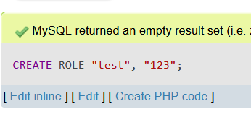

2) **Grant select, update to test on emp table**

QUERY:

GRANT SELECT, UPDATE on emp to test;

OUTPUT:

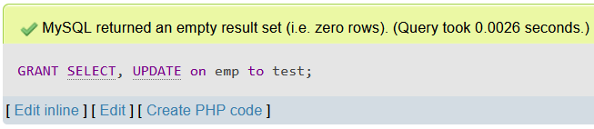

3) **Revoke select, update to test on emp table**

QUERY:

REVOKE [SELECT](https://localhost/phpmyadmin/url.php?url=https://dev.mysql.com/doc/refman/8.0/en/select.html), [UPDATE](https://localhost/phpmyadmin/url.php?url=https://dev.mysql.com/doc/refman/8.0/en/update.html) on emp from test;

OUTPUT:

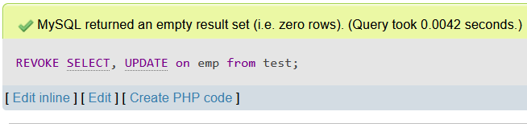

4) **Grant all on emp to test**

QUERY:

GRANT all on emp to test;

OUTPUT:

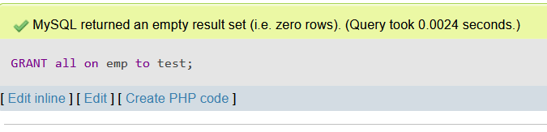

4) **Drop the role**

QUERY:

DROP role "test";

OUTPUT:

